Solution:

**Creating EC2 Instance**

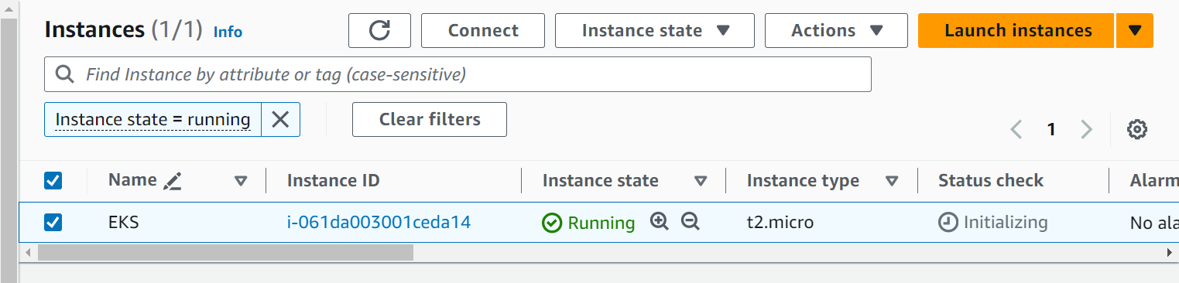  
**Installing docker**

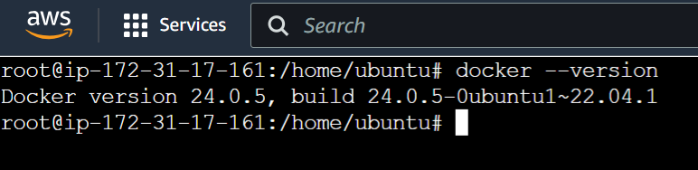

**Installing kubectl**



**Installing eksctl**

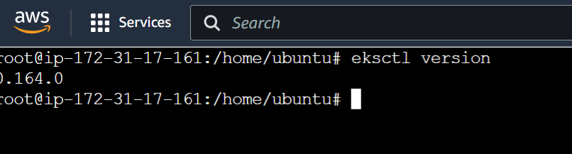

**Installing AWSCLI**

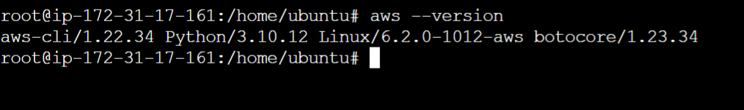

**Creating an IAM user**

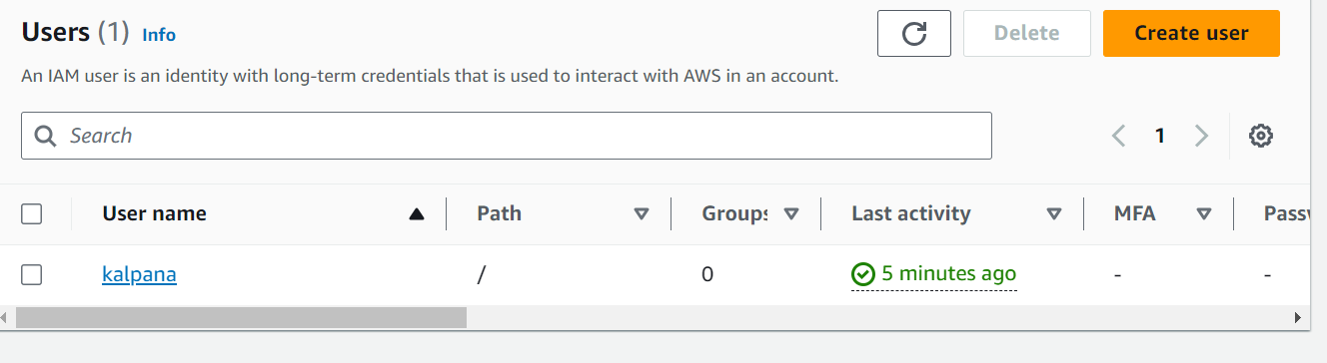

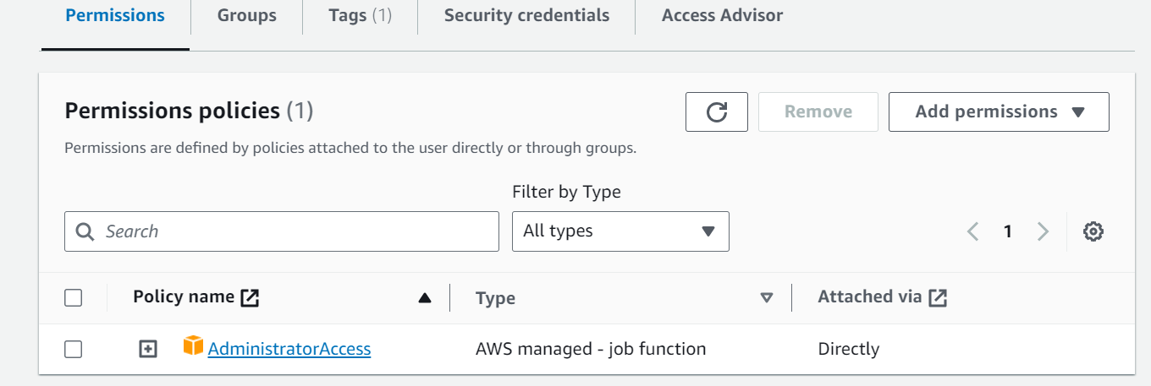

**Creating a access key and secret key from IAM user**

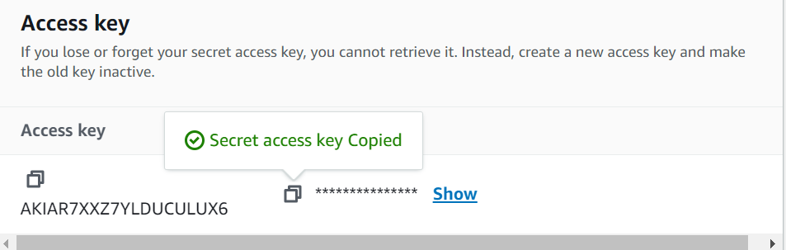

**Configuring aws credentials**

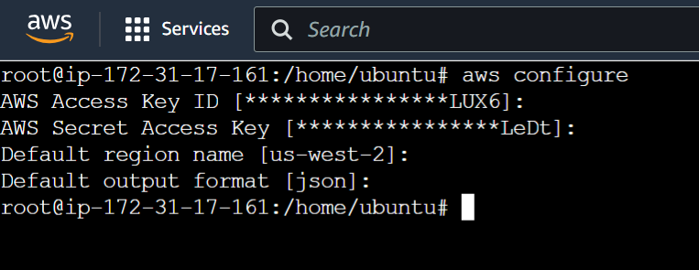

**Creating a cluster via eksctl**

**eksctl create cluster --name kalpana \**

**--region us-west-2 \**

**--node-type t2.small \**

**--nodes-min 1 \**

**--nodes-max 2 \**

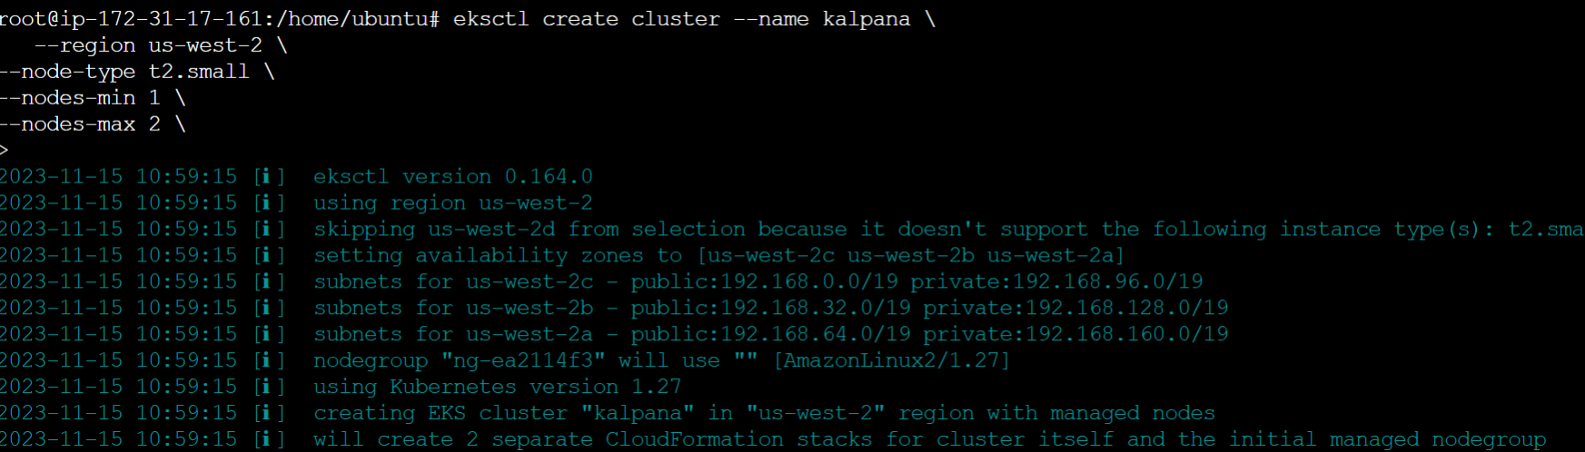

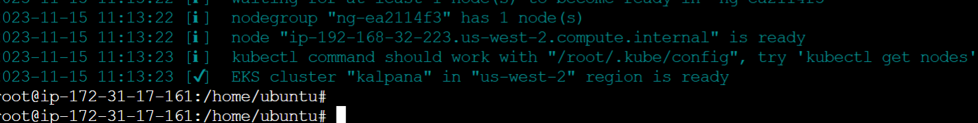

**Checking the cluster results**

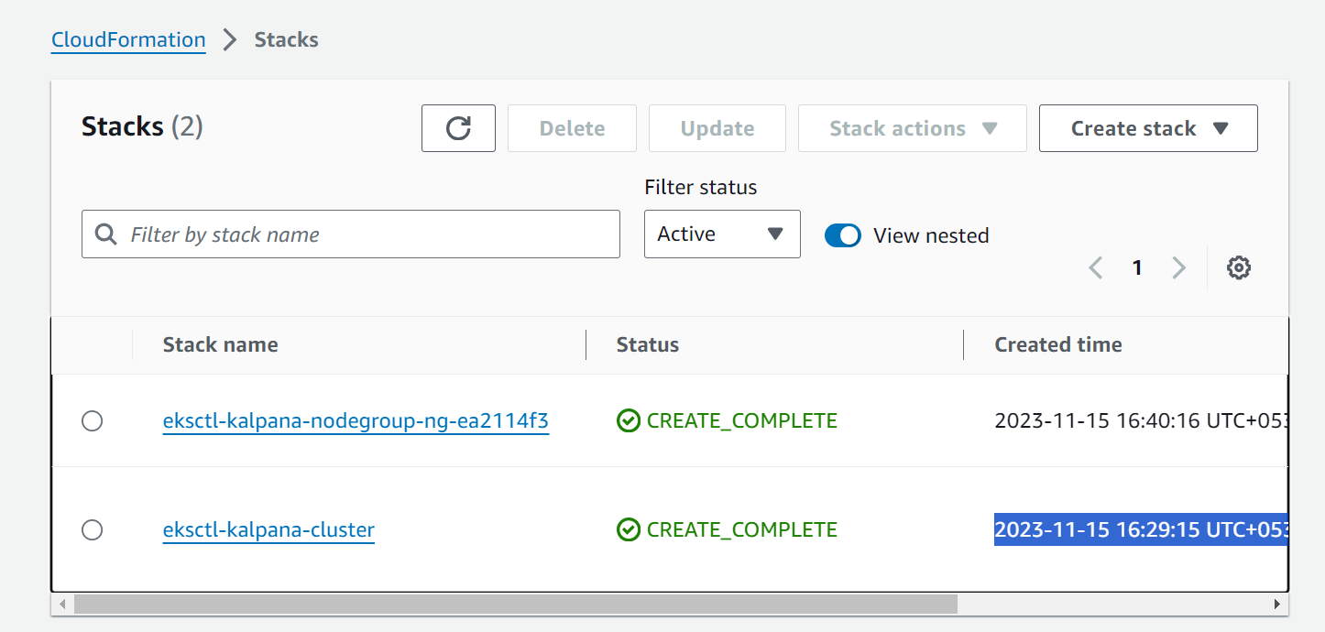

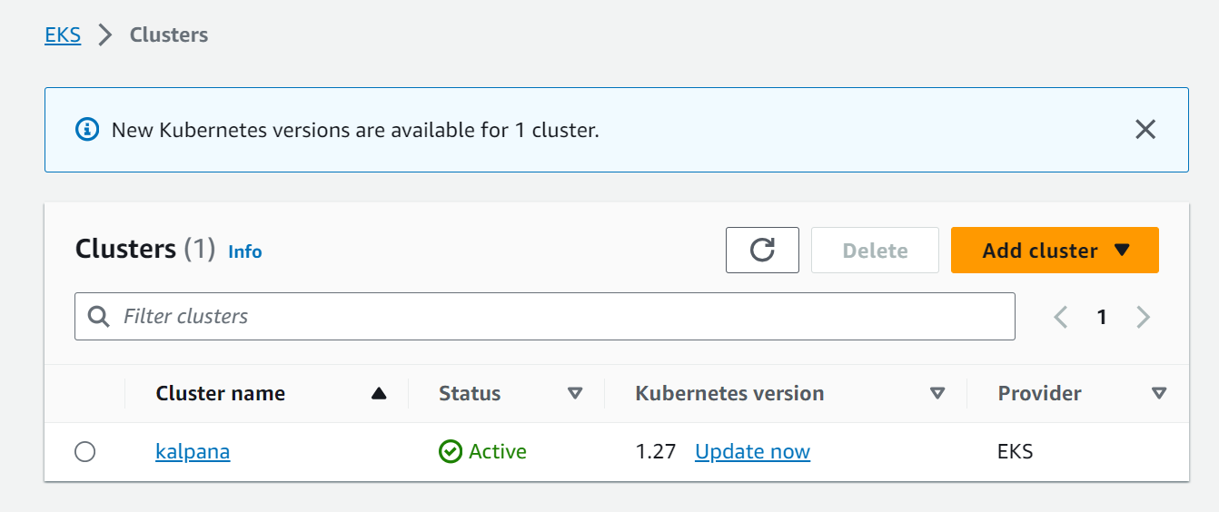



**Nginx deployment**

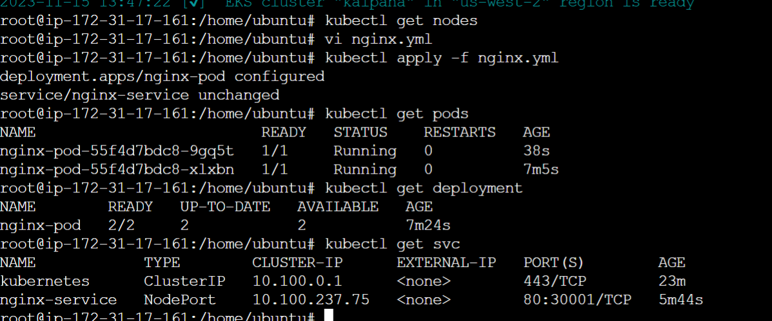

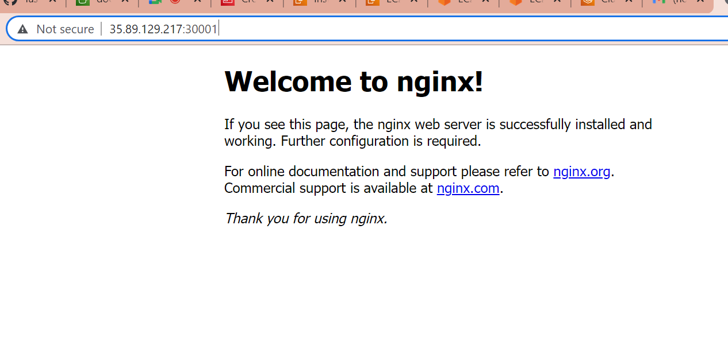

**Source code**

apiVersion: apps/v1

kind: Deployment

metadata:

  name: nginx-pod

spec:

  replicas: 2

  selector:

    matchLabels:

      app: nginx

  template:

    metadata:

      labels:

        app: nginx

    spec:

      containers:

      - name: nginx-container

        image: nginx

        ports:

         - containerPort: 80

---

apiVersion: v1

kind: Service

metadata:

  name: nginx-service

spec:

  type: NodePort

  selector:

    app: nginx

  ports:

  - port: 80

    targetPort: 80

    nodePort: 30001